PropLogix

PURPOSE: To demonstrate how to set up and use the PropLogix search integration. PropLogix allows customers to order municipal lien searches, association estoppels, payoff tracking (release tracking), and surveys from within ResWare.

NOTE: Before enabling this integration, please register for an account with PropLogix at www.proplogix.com. Then contact support@adeptivesw.com to enable this integration in ResWare and provide the login email and password created with PropLogix. After completing the setup instructions in this job aid, PropLogix will need to have the following items provided to them to complete the integration setup:

Employee partner email and password

Five DocumentTypeID’s

ResWare website URL
Version information: Functionality available in 9.4 with single credential access. An enhancement in 9.7 includes the ability for multiple login credentials. Internal user access can then be mapped to credentials. Credentials are selected on the Search/PropLogix panel.

Table of Contents
Create a PropLogix partner 2
Create a partner employee 2
Password validation 3
Set up the XML client information 4
Internal user access 5
Set up XML tab on products 6
Set up document types 7
Set-up an action and affect to automate order placement with PropLogix 9
On a file – automatic order placement 10
On a file – manual order placement 11
On the file - XML activity 14

Create a PropLogix partner

Admin/Partners

Click New.

Enter the partner’s information and set the Partner Type to Searcher.

Click Save.

Note: This partner will need to be added to each file on which orders will be sent to PropLogix.
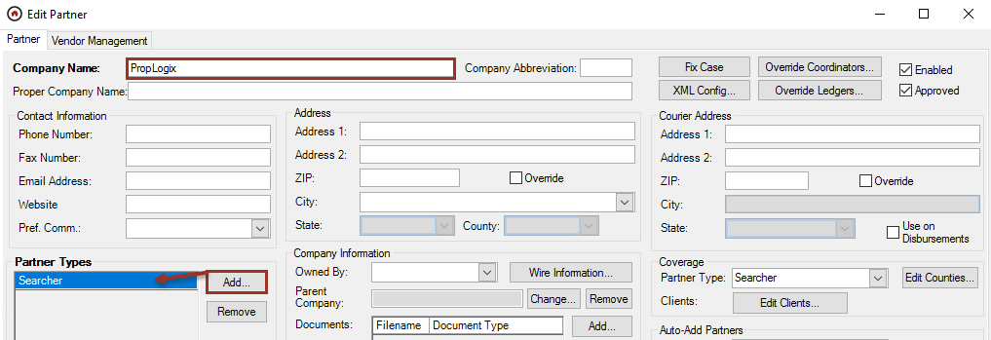

Create a partner employee

Admin/Partners

Highlight the partner created above and click New in the partner employee area.

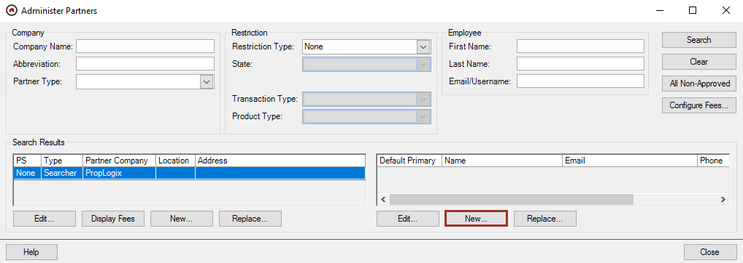

Enter a First Name.

Enter an Email Address.
- Check Primary Contact, which will default this employee to the primary contact when the partner is added to the file.

Check Enabled in the Website Access area.

Click Generate to populate a Password. This will ensure company-specific password requirements are met. Write down this password to use in the validation step.

Click Save.
Note: The username and password for the employee will need to be provided to PropLogix to allow the documents to be returned to the file’s Documents panel.
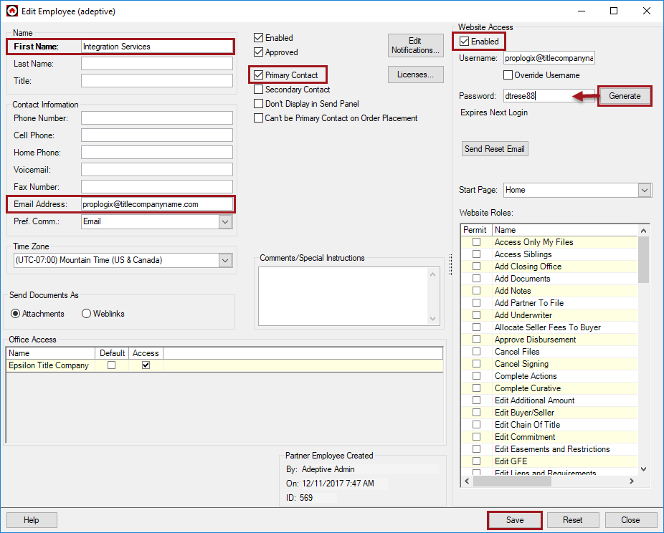

Password validation

Website

After a password is set or reset for a partner employee, the employee is required to enter a new password the next time they access the website. To ensure this integration is set up properly, log into the company’s ResWare website with the username and password created in the prior step and create a new password. Provide this new password to PropLogix.
Note: It may be beneficial to set the expiration date of this password on the partner employee setup out for an extended period of time. Check with company-specific password security protocols to verify this will be acceptable or have a reminder in place to update this password as needed to ensure this integration’s service will not be interrupted.
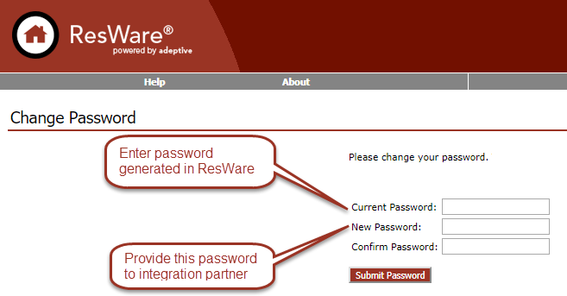

Set up the XML client information

Admin/General Setup/XML Clients

Highlight PropLogix and click Edit.

Check Enabled to enable the integration.

Enter the Web Service URL as https://api.proplogix.com

Click Add to enter the credentials provided by PropLogix.

Enter a Display Name that will be displayed when selecting this account on the Search Panel.

Enter the Username provided by PropLogix for this account.

Enter the Password provided by PropLogix for this account.

In the For Offices area, if this account is for specific offices, check Selected, then click Add to add the office or offices where this account is available; otherwise leave as All.

In the Partners area, if this account is associated with a specific partner, check Selected, then click Add to add the partner or partners where this account is available; otherwise leave as All.

Click Save.

Repeat the above steps for each set of credentials provided by PropLogix.
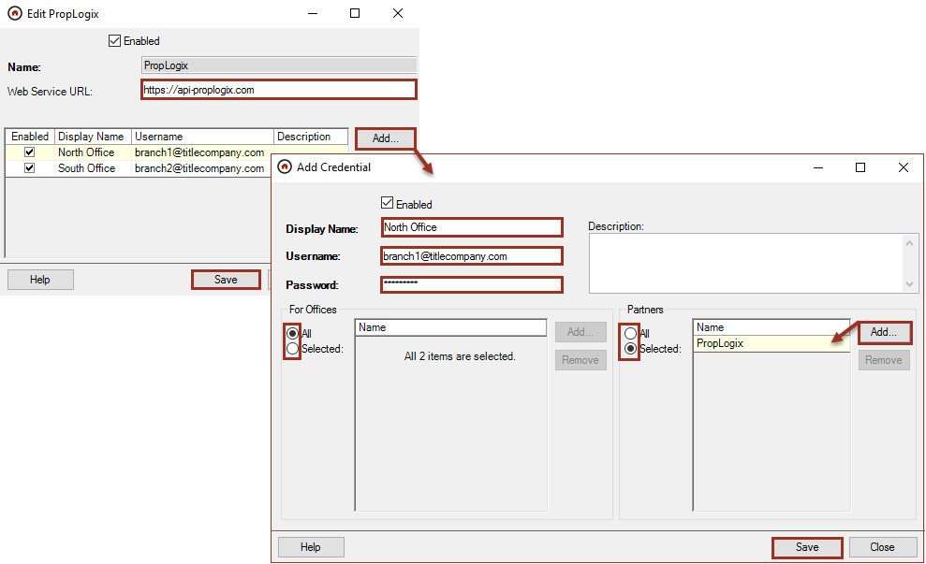

Internal user access

Admin/Internal User/External Service Accounts
Access to the PropLogix accounts must be assigned at the user level.

Select PropLogix in the XML Clients drop-down menu, if not already selected.

Click Add, then select the account or accounts as needed.

Click Add, then Save.
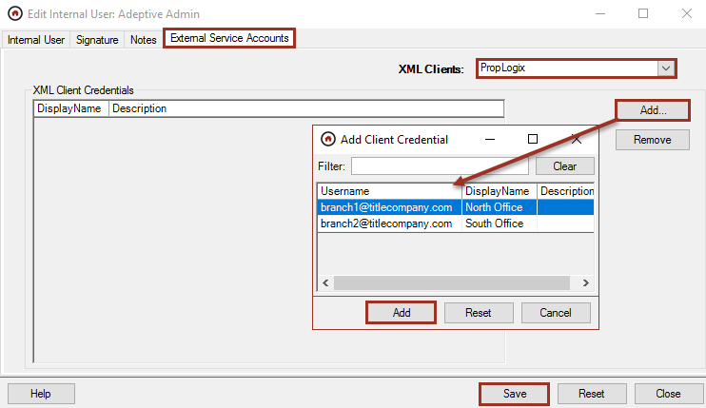

Set up XML tab on products

Admin/Action Lists/Product Types

Edit each product on which enabling PropLogix functionality is needed.

Click XML tab.

Click Add and select PropLogix.

Click OK.

Click Save.

Click Close.
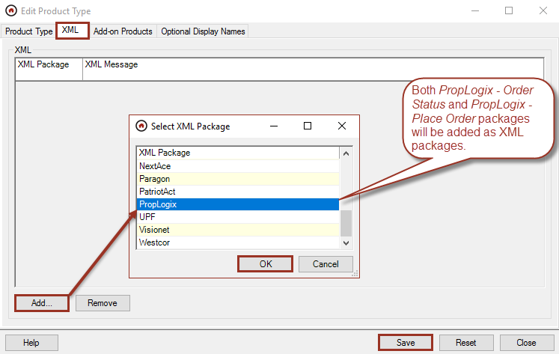

Set up document types

Admin/Documents and Templates/Document Types

Five document types (Invoice, Lien Search, Estoppel, Payoff Tracking, and Survey) will need to already exist or be created in ResWare to allow PropLogix to return the different ordered products along with an accompanying invoice as .pdf documents on the file.
Add new document types

Add to create a new Document Type as needed for each PropLogix product along with one for an invoice.

Enter Name.

Click Save.

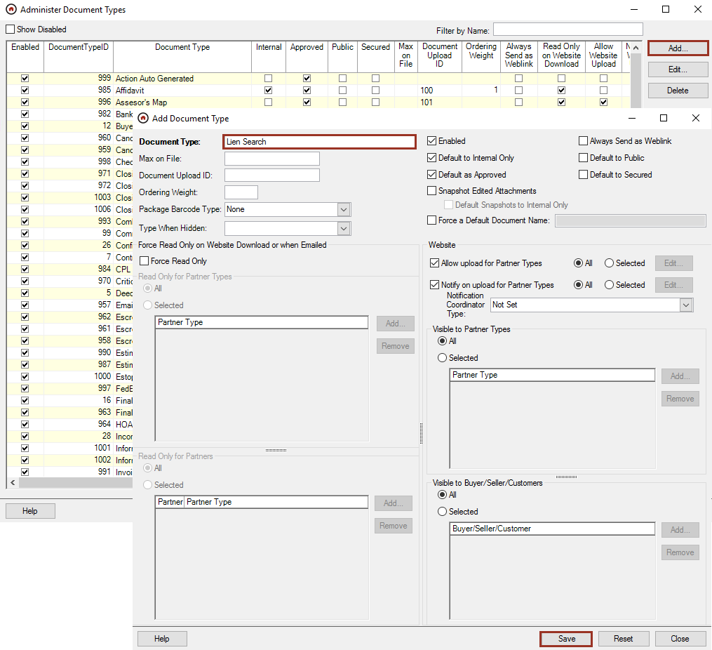

The DocumentTypeID’s for each document need to be provided to PropLogix to ensure the correct mapping.

Right click in grid.

Select Show Column.

Select DocumentTypeID.
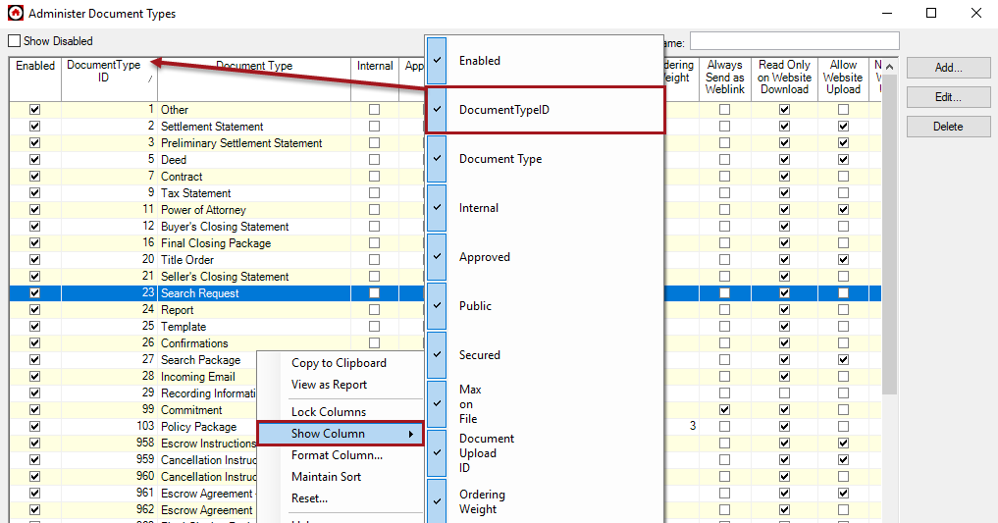

Set-up an action and affect to automate order placement with PropLogix

This only needs to be done if ordering searches with PropLogix should be done based on an action being completed. If users are going to manually send orders to PropLogix, skip this step.

Note: An order sent via an action will only request a lien search product with a default set of options. If other PropLogix products are needed, a user will need to order manually from the Search Data/PropLogix panel.

Admin/Action Lists/Action Groups

Highlight the action group that has the action that should send the search and click Edit Actions.

Highlight the action that should be used to send the request and click Edit Affects.

In either the Start Task Marked Done Affects or Complete Task Marked Done Affects section, click Add.

Select the following in 5 – Marking Done Sends XML.

XML: PropLogix: PropLogix – Place Order.

Send To: Searcher.

Click Save.

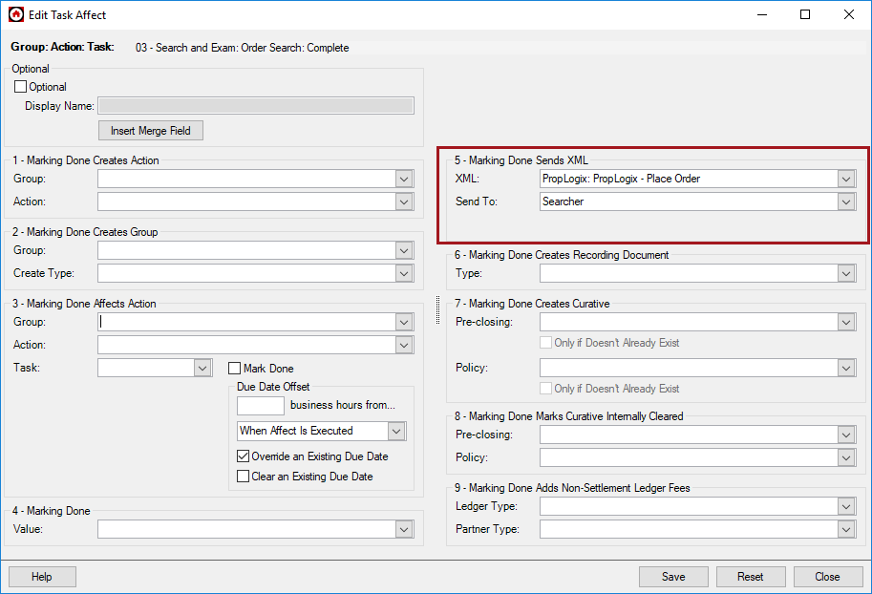

On a file – automatic order placement

File/Actions tab

The PropLogix partner must be on the file in order to send search requests. The file must have an Estimated Settlement Date entered on the General panel.

Highlight the action being used to send the search request to PropLogix and click either Mark Started or Mark Completed, depending on where the affect was set.

A lien search order will be sent to PropLogix with the following options:

Property Appraiser

Property Taxes

Tangible Taxes

Open Code Cases

Closed Code Cases

Open and Expired Permits

Closed Permits

Utilities

Special Assessments

The search document will be returned from PropLogix and added to the Documents tab of the file when complete as on of the five document types PropLogix requires (Invoice, Lien Search, Estoppel, Payoff Tracking, or Survey).

On a file – manual order placement

File/Search Data/PropLogix

The PropLogix partner must be on the file in order to send search requests.
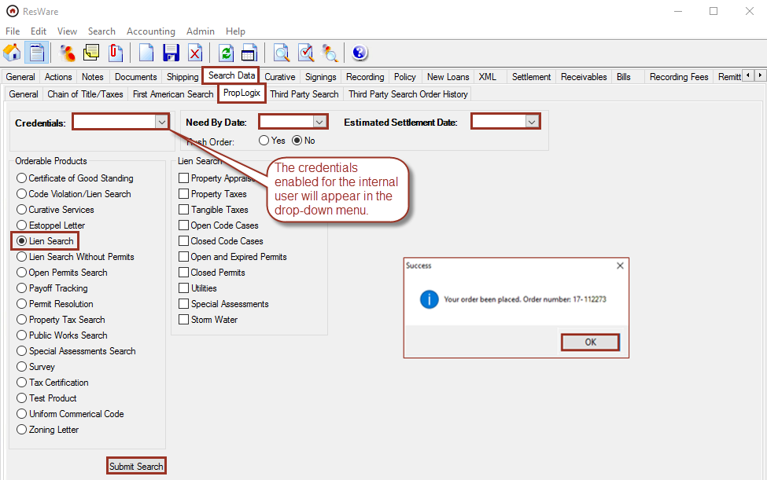

Select an option in the Orderable Products column.

Enter a Need by Date.

Enter an Estimated Settlement Date.

Select the Lien Search options. These options vary based on the type of product selected.

Click Search. This will send the request to PropLogix.

Click OK on the popup showing the order was placed.

PropLogix will return the ordered product with an accompanying invoice on the Documents panel. Action triggers may be set up based on documents of these types being added to the file.
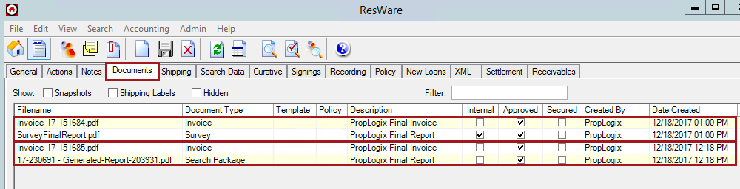

If an estoppel letter is being ordered, the user will be presented with additional fields; fields in bold are required. The Listing Agent fields will be populated from the Listing Agent partner on the file, if it exists. Title Commitment, Certificate of Title, Contract, or Authorization Form documents can be added from the file or attached from the user’s computer by using the Choose File drop down menu.
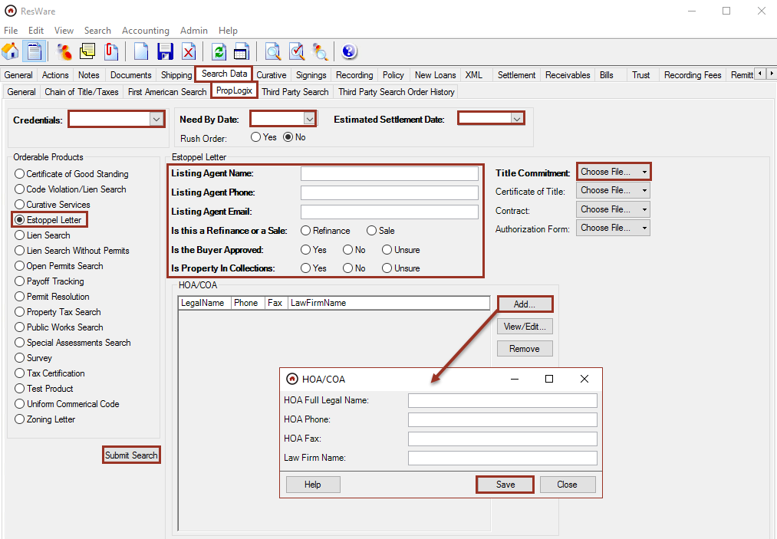

If payoff tracking (release tracking) is being ordered, the user will be presented with additional fields; fields in bold are required. The Seller Name and Buyer Name will be populated from the buyer/seller partners on the file, if they exist.
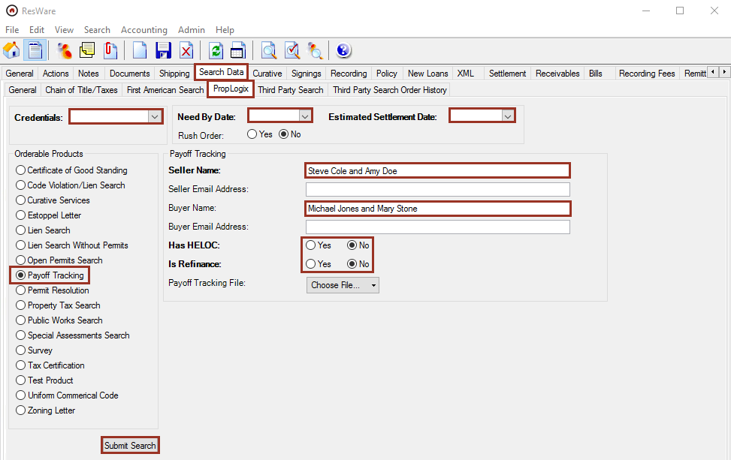

If a survey is being ordered, the user will be presented with additional fields; fields in bold are required. Survey Type, Survey Purpose, and Elevation Certificate each have dropdown selections available. If either a Survey Certification or Survey Hard Copy Requests are added, additional fields will be required as shown.
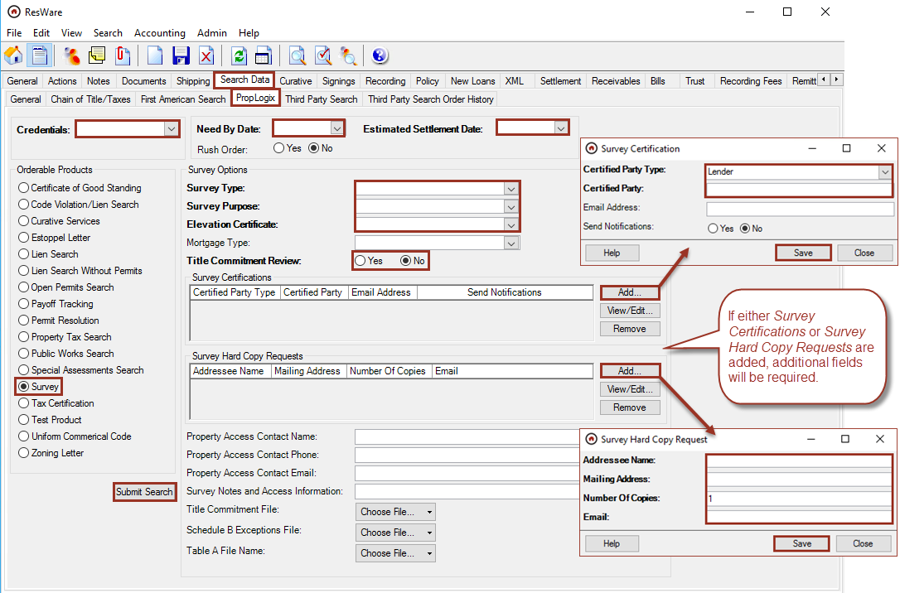

On the file - XML activity

File/XML

This panel shows activity from the initial order placement to the documents being returned from PropLogix for the services ordered.
